HANOI UNIVERSITY OF SCIENCE AND TECHNOLOGY

School of Information and Communications Technology

ITSS Software Development Report

**EcoBikeRental**

Subject: Software Development

Instructor: Prof. Trinh Tuan Dat

Student: Tran Le Hoang - 20176764

*Hanoi, December 2020*

1. Assigned Use Case
   1. Usecase diagram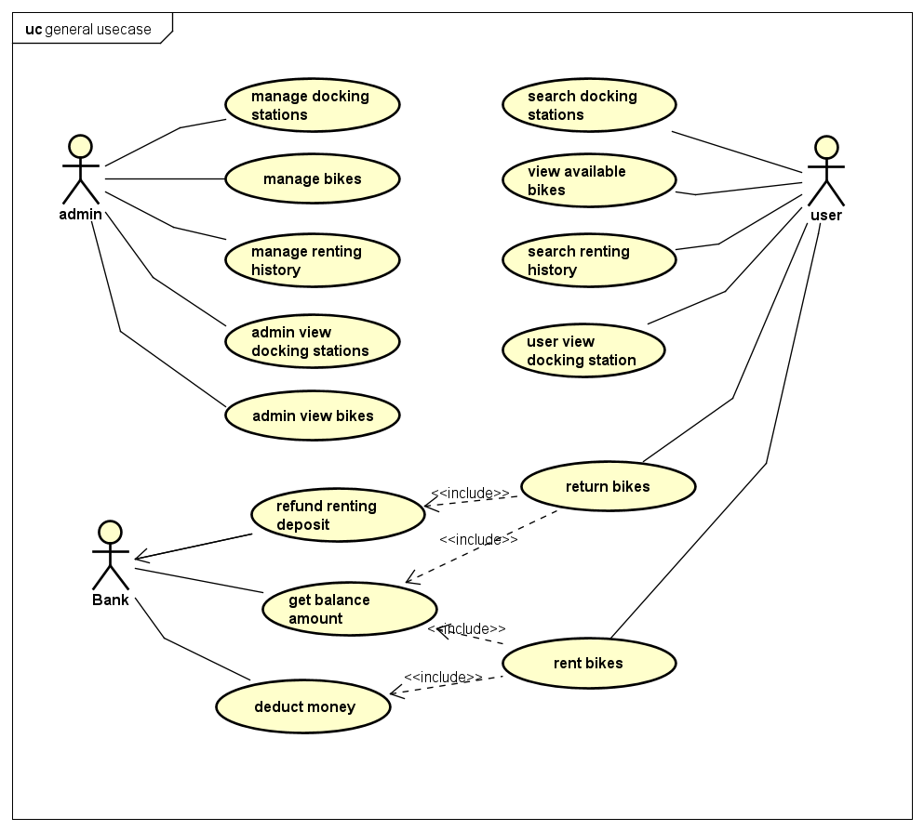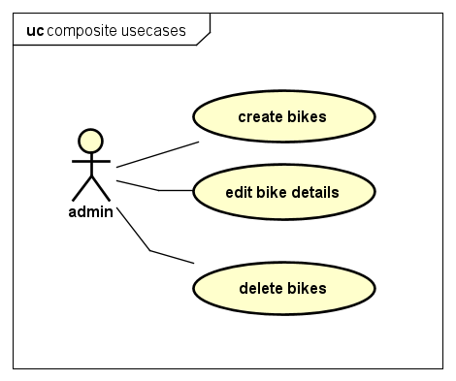
   2. Usecase specification

|  |  |  |  |
| --- | --- | --- | --- |
| UC Code | UC001 | Use case name | Edit bike details |
| Actor | Admin | | |
| Description | The “edit bike details” use case is initiated when admin press edit button in the bike detail page. Subsequently, a new page with title “Update bike details” appears containing current information about the selected bike. Admin can then edit each individual fields. The page can be dismissed by clicking either “Save” or “Cancel” button. Pressing “Save” button will result in the entry of selected bike be updated to reflect changes, while “Cancel” button made no changes to that bike | | |
| Precondition | Admin successful Login | | |
| Main flow of event (success) | | # | Doer | Action | | --- | --- | --- | |  | Admin | Choose edit bike button in bikes page | |  | Software | displays admin edit bike screen | |  | Software | Update details in edit screen with selected bike | |  | Admin | enters bike details to update | |  | Admin | Choose save bike button | |  | Software | checks if the entered detail fields is valid | |  | Software | Save updated bike if details is valid | |  | Software | Displays successfully update bike detail message | |  | Software | Close edit page and return to bike list page | | | |
| Alternative flow of event | |  |  |  | | --- | --- | --- | | # | Doer | Action | |  | Admin | Cancels edit page at any time | | 4a | Admin | Clears any field before saving | | 5b | Admin | Choose cancel button | | 6a. | Software | Notifies error “Invalid field input” if the entered detail field is invalid, go to step 2 | | 6b | Software | Notifies information “No field change” if nothing is edited, go to step 2 | | | |
| Post condition | No | | |

* Bike edit input requirements:

|  |  |  |  |  |  |
| --- | --- | --- | --- | --- | --- |
| **#** | **Data field** | **Description** | **Required?** | **Valid condition** | **Example** |
| 1. | Name | The name of this bike | Yes | Characters and digits only | Eco Bike |
| 2 | Weight | The bike’s weight (in kilograms) | Yes | Numbers only | 30 |
| 3 | License Plate | The bike’s license series | Yes | Characters and digits only | ECOB12345 |
| 4 | Manufacturing Date | The bike’s manufacturing date | Yes | Check for valid date format, no future date allow | 12/10/2015 |
| 5 | Producer | The bike’s producer company | Yes | Characters and digits only | Thong Nhat |
| 6 | Cost | The bike’s cost | Yes | numbers | 100000 |
| 7 | Docking station Id | The bike’s current station | Yes | Check existed station id | Ds1 |

1. Diagrams
   1. Sequence Diagram for Analysis Class

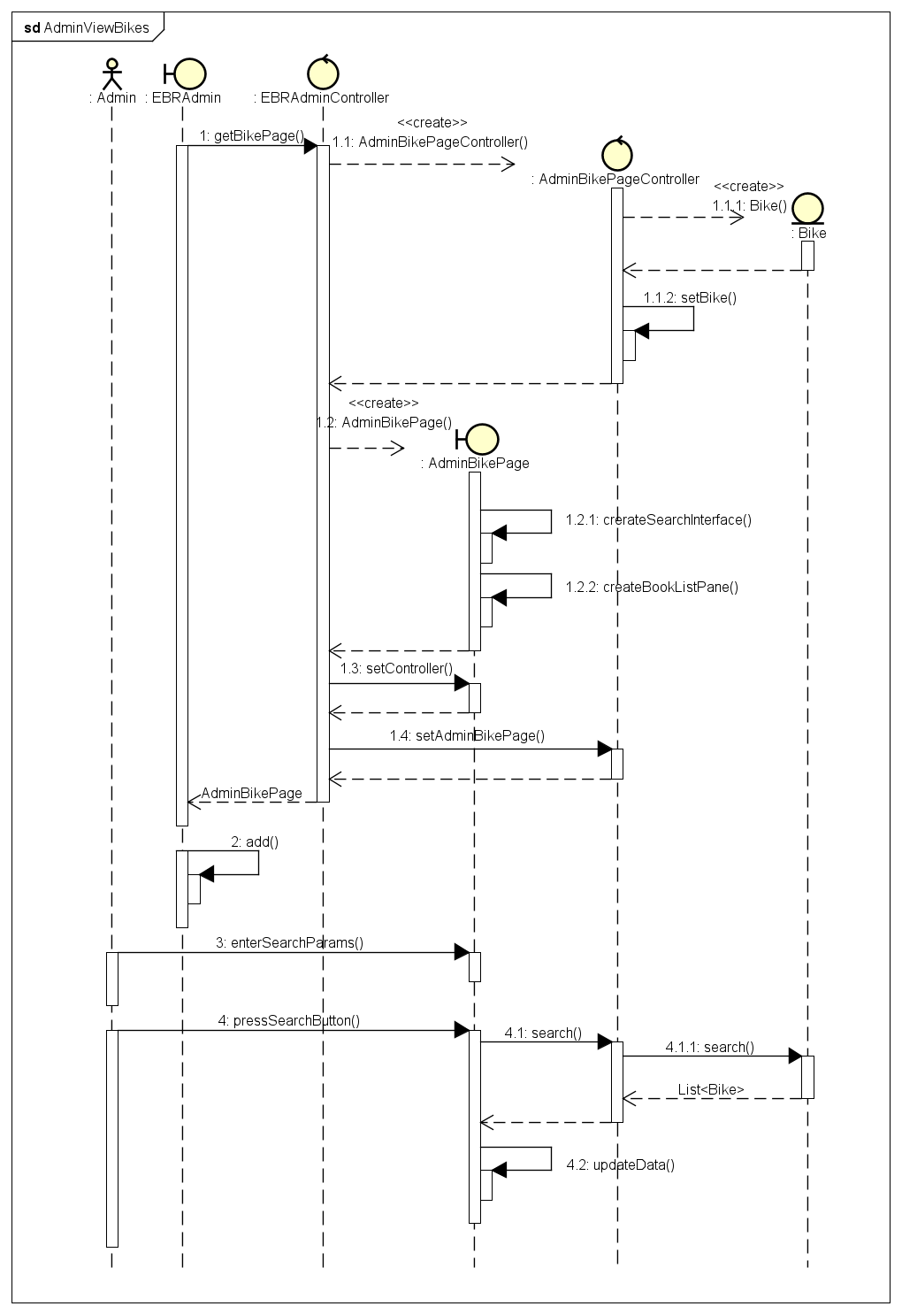

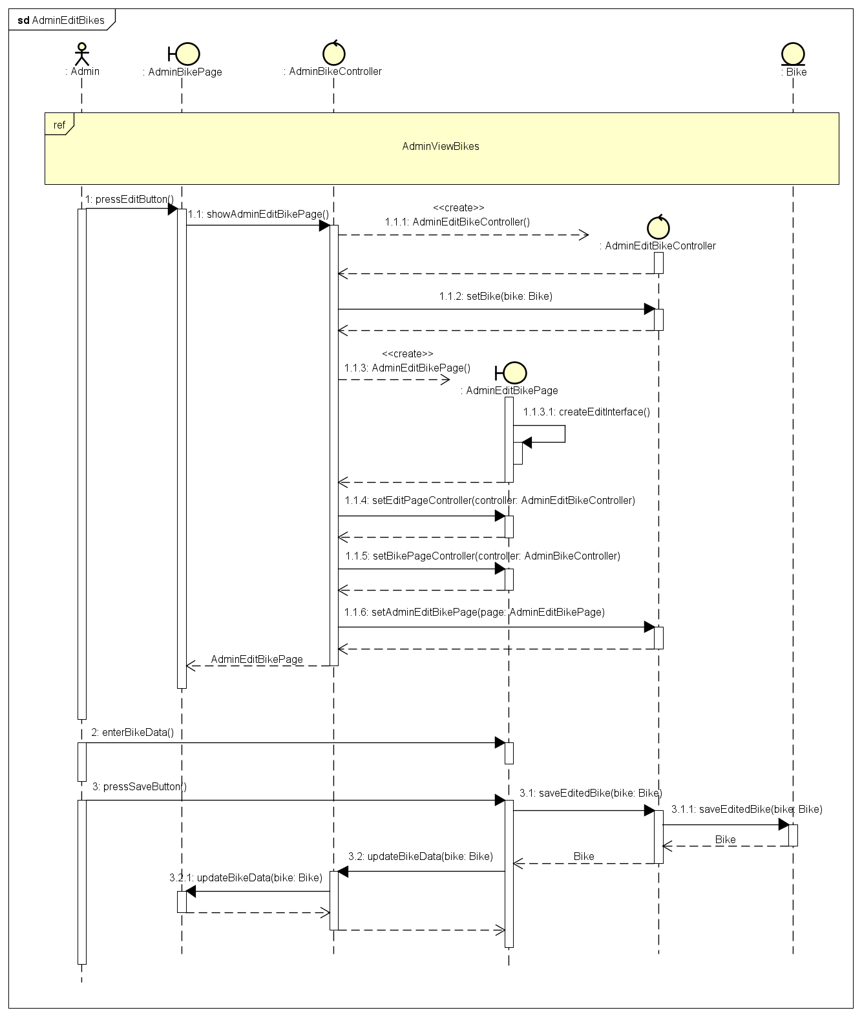

* 1. Analysis Classes

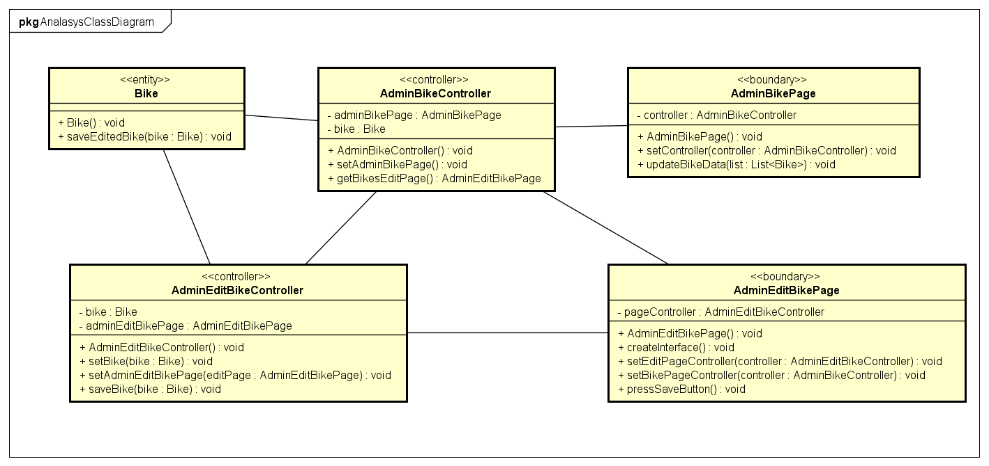

* 1. Package Diagram

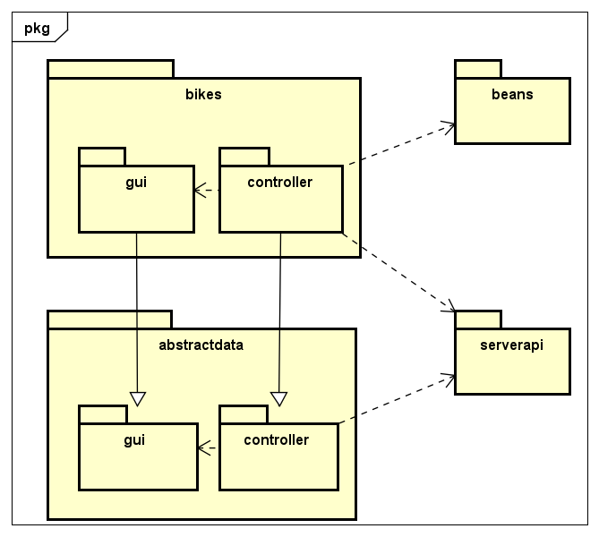

* 1. Sequence Diagram for Design Class

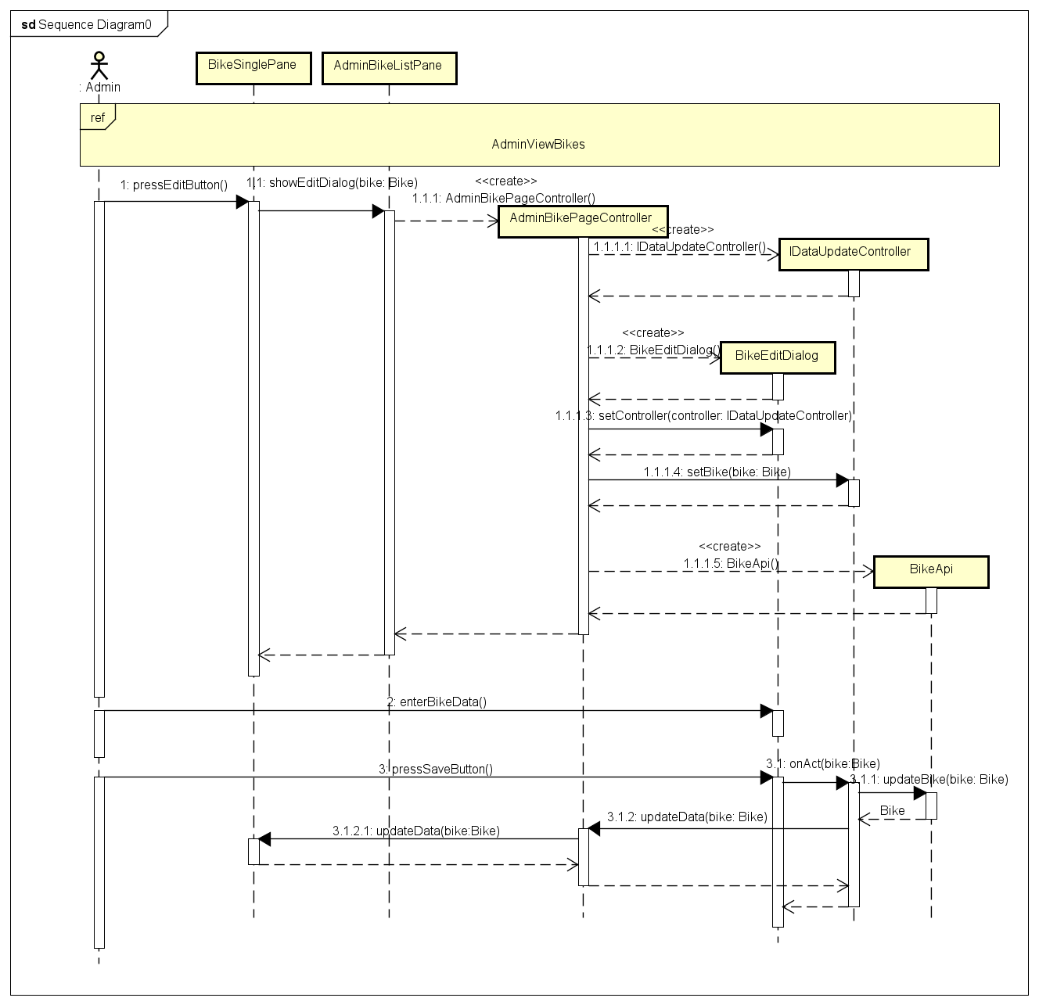

* 1. Design Classes

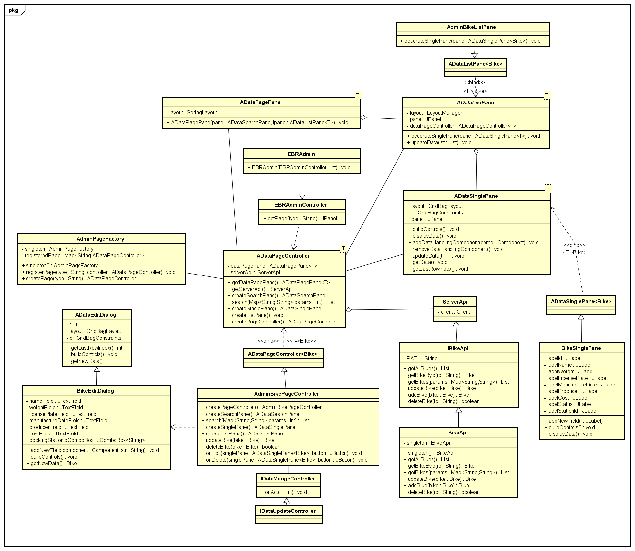

1. Unit Testing

|  |  |  |  |  |
| --- | --- | --- | --- | --- |
| Test Case Name: Edit Bike | | Technique applied: Black Box | | |
| Description: Test the edit bike functionality | | | | |
| Pre-conditions: Successfully log in as admin | | | | |
|  | | | | |
| Step | Action | Expected System Response | Pass/Fails | Comment |
| 1 | Enter ‘normalBikeEdit’ in Name Field | ‘normalBikeEdit’ displayed in Name field | pass |  |
| 2 | Press Save | Information of name-field-edited bike displayed in bike list pane | Pass |  |
| 3 | Leave Name Field Blank | Name field displayed nothing | Pass |  |
| 4 | Press Save | A Dialog inform that Name field is blank and allow user to re-enter name field | pass |  |
| 5 | Enter ‘123 in Weight Field | ‘123 displayed in Weight field | Pass |  |
| 6 | Press Save | Information of weight-field-edited bike displayed in bike list pane | Pass |  |
| 7 | Leave Weight Field Blank or enter characters | Name field displayed corresponding text | Pass |  |
| 8 | Press Save | A Dialog inform that Weight field is invalid and allow user to re-enter weight field | Pass |  |
| 9 | Enter ‘29B in License plate Field | ‘29B displayed in Name field | pass |  |
| 10 | Press Save | Information of licenseplate-field-edited bike displayed in bike list pane | Pass |  |
| 11 | Leave License Plate Field Blank | Name field displayed nothing | Pass |  |
| 12 | Press Save | A Dialog inform that License Plate field is blank and allow user to re-enter license plate field | pass |  |
| 13 | Enter ‘12/12/2020’ in Date Field | ‘12/12/2020’ displayed in Date field | pass |  |
| 14 | Press Save | Information of date-field-edited bike displayed in bike list pane | Pass |  |
| 15 | Leave date Field Blank or enter ‘123123123xxx’ or enter ’12/2/2090’ | Display corresponding text | Pass |  |
| 16 | Press Save | A Dialog inform that date field is invalid and allow user to re-enter date field | pass |  |
| 17 | Enter ‘prod1’ in Producer Field | ‘prod1’ displayed in Date field | pass |  |
| 18 | Press Save | Information of producer-field-edited bike displayed in bike list pane | Pass |  |
| 19 | Leave Producer Field Blank | Display nothing in producer field | Pass |  |
| 20 | Press Save | A Dialog inform that producer field is empty and allow user to re-enter producer field | pass |  |
| 21 | Enter ‘120000’ in Cost Field | ‘120000’ displayed in Date field | pass |  |
| 22 | Press Save | Information of cost-field-edited bike displayed in bike list pane | Pass |  |
| 23 | Leave Cost Field Blank or enter ‘12x3333’ | Display corresponding text | Pass |  |
| 24 | Press Save | A Dialog inform that cost field is invalid and allow user to re-enter cost field | pass |  |